FOR IMMEDIATE RELEASE
May 2, 2025
BEGA Releases Quarterly Complaint Summary Report for FY2025 Quarter Two
The District of Columbia Board of Ethics and Government Accountability (“BEGA”) today released its Quarterly Complaint Summary Report for the second quarter of FY 2025, covering the period from January 1, 2025 through March 31, 2025.
During FY2025 Q2, the Office of Government Ethics (“OGE”), an office within BEGA that investigates alleged violations of the District’s Code of Conduct by employees and public officials, closed 66 matters. Fifty percent of the matters closed during this quarter (34 out of 66 matters) involved allegations that were outside of BEGA’s jurisdiction.

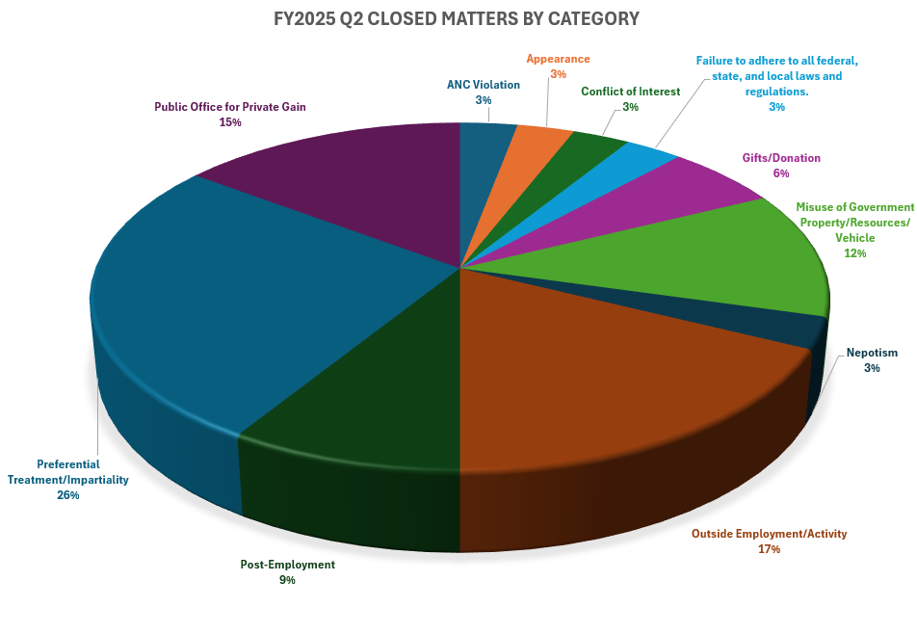
For the 34 closed matters within BEGA’s jurisdiction, allegations of preferential treatment and lack of impartiality topped the list, accounting for nine matters (26%). Potential violations of the rules governing outside employment or activities accounted for six matters (18%), while allegations of using public office for private gain were involved in five matters (15%), and misuse of government property/resources/vehicle were involved in four matters (12%). Two matters involved potential violations of the gifts rule (6%), while there was one matter each (3%) for alleged violations of the rules governing Advisory Neighborhood Commissions, conflict of interest and appearance of a conflict of interest, nepotism, and failure to adhere to all federal, state, and local laws and regulations.
Code of Conduct Category | Number | Percent
Preferential Treatment/Impartiality | 9 | 26.47%
Outside Employment/Activity | 6 | 17.65%
Public Office for Private Gain | 5 | 14.71%
Misuse of Government Property/Resources/Vehicle | 4 | 11.76%
Post-Employment | 3 | 8.82%
Gifts/Donation | 2 | 5.88%
ANC Violation | 1 | 2.94%
Appearance | 1 | 2.94%
Conflict of Interest | 1 | 2.94%
Failure to adhere to all federal, state, and local laws and regulations. | 1 | 2.94%
Nepotism | 1 | 2.94%

The summary of closed matters and additional information can be found on BEGA’s Ethics Heatmap (https://bega.dc.gov/page/ethics-heatmap), which will be updated with additional data as it is available.

